Introduction to HTML/CSS Exercise Solution Ankit

Group 5

Ques. 1 How are inline and block elements different from each other?

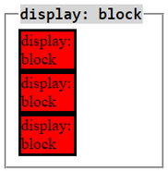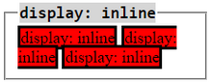

A block-level element always starts on a new line and takes up the full width available (stretches out to the left and right as far as it can).

An inline element does not start on a new line and only takes up as much width as necessary.

Ques. 2 Explain the difference between visibility:hidden and display:none

visibility:hidden leaves the element in the normal flow of the page such that is still occupies space.

display:none removes the element from the normal flow of the page, allowing other elements to fill in.

Ques. 3 Explain the clear and float properties.

The float property is used for positioning and formatting content e.g. let an image float left to the text in a container. The float property can have one of the following values:

* left - The element floats to the left of its container
* right- The element floats to the right of its container

The clear property specifies what elements can float beside the cleared element and on which side. The clear property can have one of the following values:

* left - No floating elements allowed on the left side
* right- No floating elements allowed on the right side
* both - No floating elements allowed on either the left or the right side

Ques. 4 Explain difference between absolute, relative,fixed and static.

Absolute :

An element with position: absolute; is positioned relative to the nearest positioned ancestor However; if an absolute positioned element has no positioned ancestors, it uses the document body, and moves along with page scrolling.

Relative :

An element with position: relative; is positioned relative to its normal position. Setting the top, right, bottom, and left properties of a relatively-positioned element will cause it to be adjusted away from its normal position. Other content will not be adjusted to fit into any gap left by the element.

Fixed :

An element with position: fixed; is positioned relative to the viewport, which means it always stays in the same place even if the page is scrolled. The top, right, bottom, and left properties are used to position the element. A fixed element does not leave a gap in the page where it would normally have been located.

Static :

HTML elements are positioned static by default. Static positioned elements are not affected by the top, bottom, left, and right properties. An element with position: static; is not positioned in any special way; it is always positioned according to the normal flow of the page:

Ques. 5 Write the HTML code to create a table in which there are 4 columns( ID , Employee Name, Designation, Department) and at least 6 rows. Also do some styling to it.

Refers to **table.html** in folder.

Ques. 6 Why do we use meta tags?

The <meta> tag provides metadata about the HTML document. Metadata will not be displayed on the page, but will be machine parsable. Meta elements are typically used to specify page description, keywords, author of the document, last modified, and other metadata.

Ques. 7 Explain box model.

The CSS box model is essentially a box that wraps around every HTML element. It consists of -: margins, borders, padding, and the actual content.

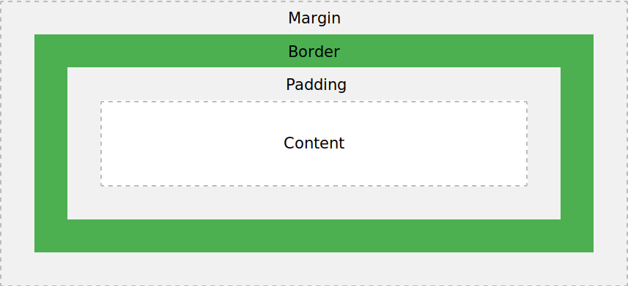

* **Content** - The content of the box, where text and images appear
* **Padding** - Clears an area around the content. The padding is transparent
* **Border** - A border that goes around the padding and content
* **Margin** - Clears an area outside the border. The margin is transparent

Ques. 8 What are the different types of CSS Selectors?

CSS Selectors are patterns used to select the element(s) you want to style.

1. Class Selector(.) - Selects all elements with class=”classname”
2. Id Selector(#) - Selects the element with id="id_name"
3. Universal Selectors(*) - Selects all elements

Ques. 9 Define Doctype.

The <!DOCTYPEhtml> declaration is used to inform a website visitor's browser that the document being rendered is an HTML document. While not actually an HTML element itself, every HTML document should being with a DOCTYPE declaration to be compliant with HTML standards.

Ques. 10 Explain 5 HTML5 semantic tags.

A semantic element clearly describes its meaning to both the browser and the developer. Examples of **semantic** elements: <form>, <table>, <header> , <nav> and <article> - Clearly defines its content.

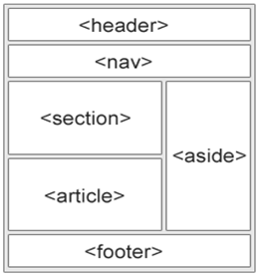

Ques. 11 Create HTML for web-page.jpg (check resources, highest weightage for answers).

Refer to **webpage.html** in folder.

Ques. 12 Create HTML for form.png (check resources, highest weightage for answers).

Refer to **form.html** in folder.